Create a html templates
-----------------------------------------------
Previously we were returning some html tags and were displaying on browser like below

def contact(request): ( Views.py )
return HttpResponse('<h2>***** OM HANUMATEY NAMHA ******** this is CONTACT PAGE page page<br><h4>Returning with httpResponse</h4></h2>')

for this we have to import below package
from django.http import HttpResponse (URLS.PY)

but this is not a good practice ,when we will have lots of html codes then may be it will be difficult
above it was only 1 /2/3/4 lines but think about the case when we need a form fillup details , in that case it will be difficult to do that
SOLUTION ---- we will return a html page / html templates

How..?
Let see below --- and create a html page (home.html) see 4th tab
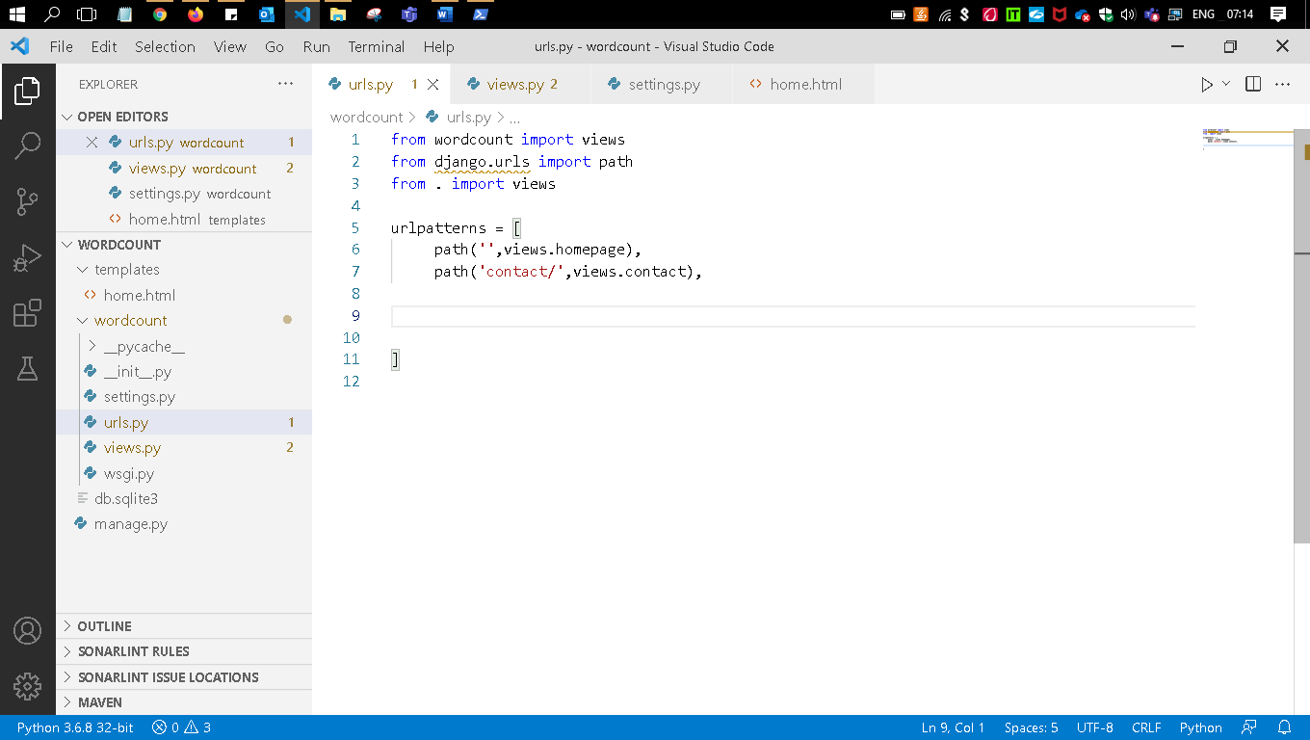
Folder structure ---
you folder ---- wordcount---- templates----home.html
you folder ---- wordcount---- wordcount----(settings,urls,views,wsgi.py)

open—views.py
from django.shortcuts import render
def homepage(request):
return render(request,'home.html')
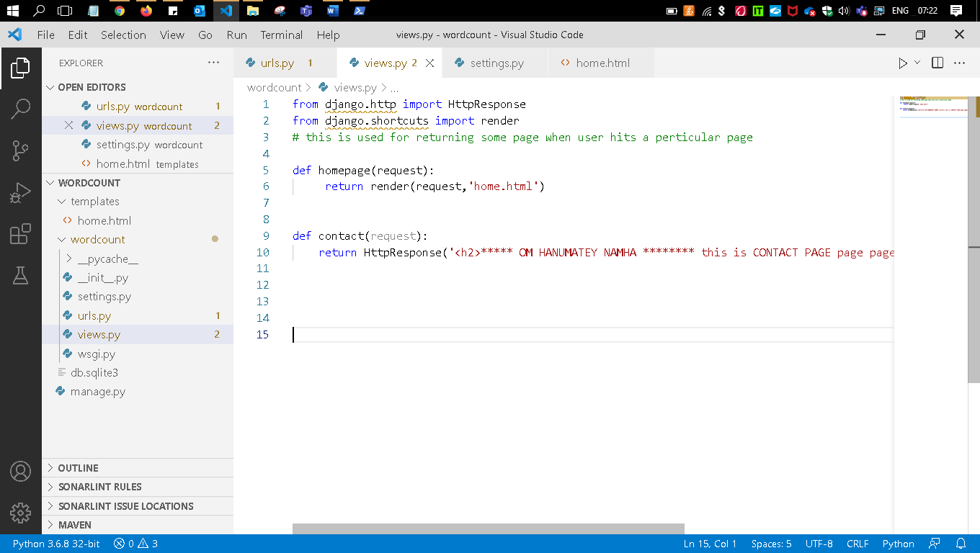

Now you have to write inside the home.html file
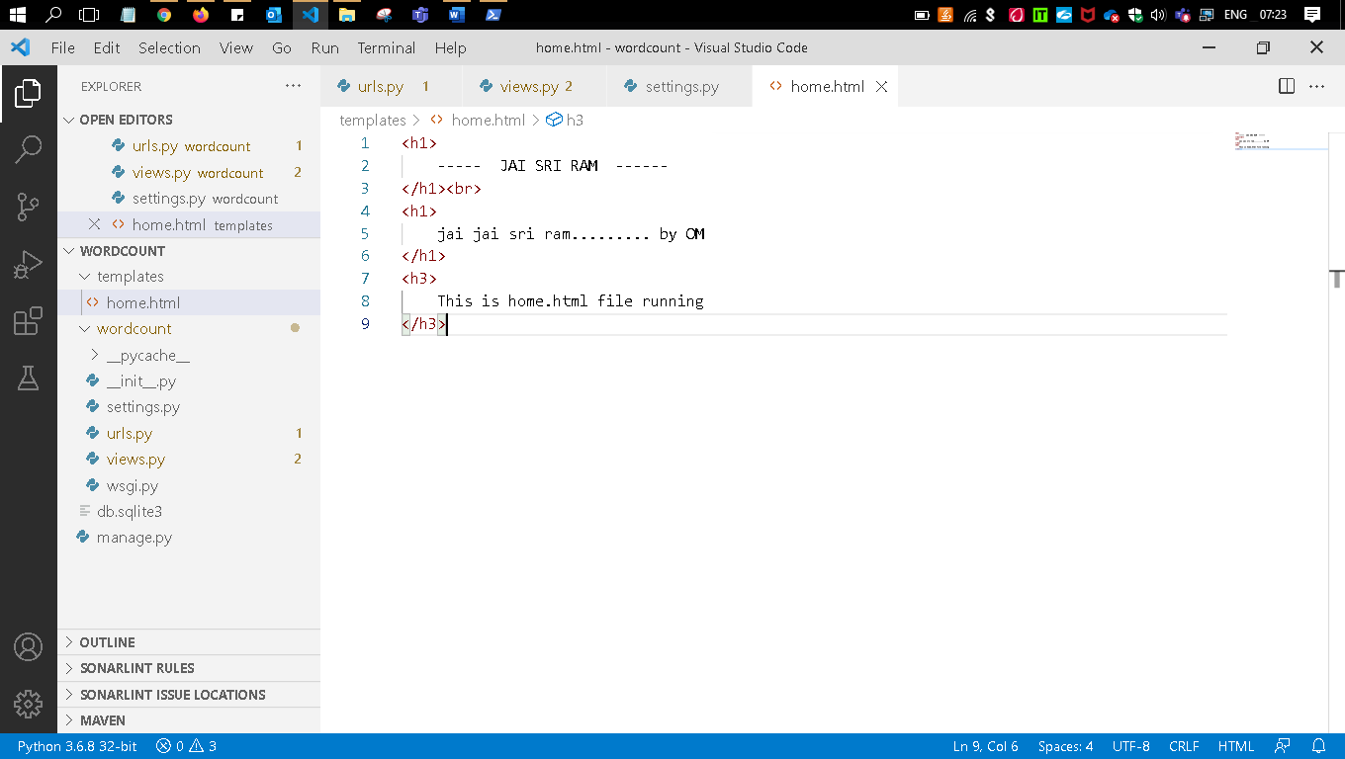

Only this thing need to be change
Rerun the server

You will get the below error

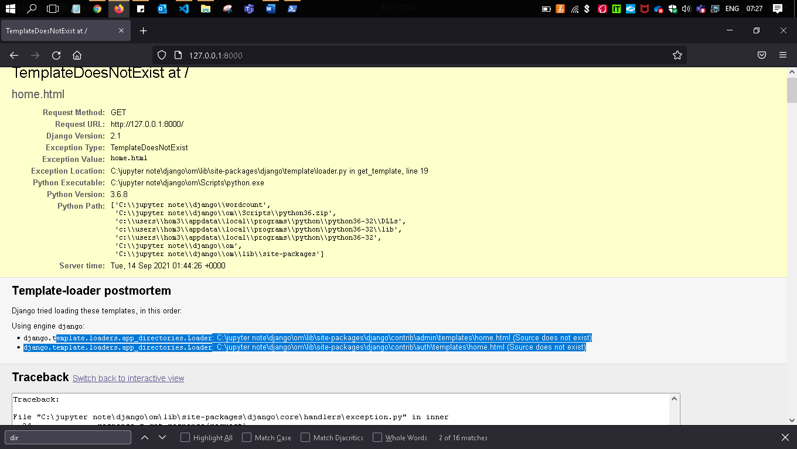

We will change in settings.py file
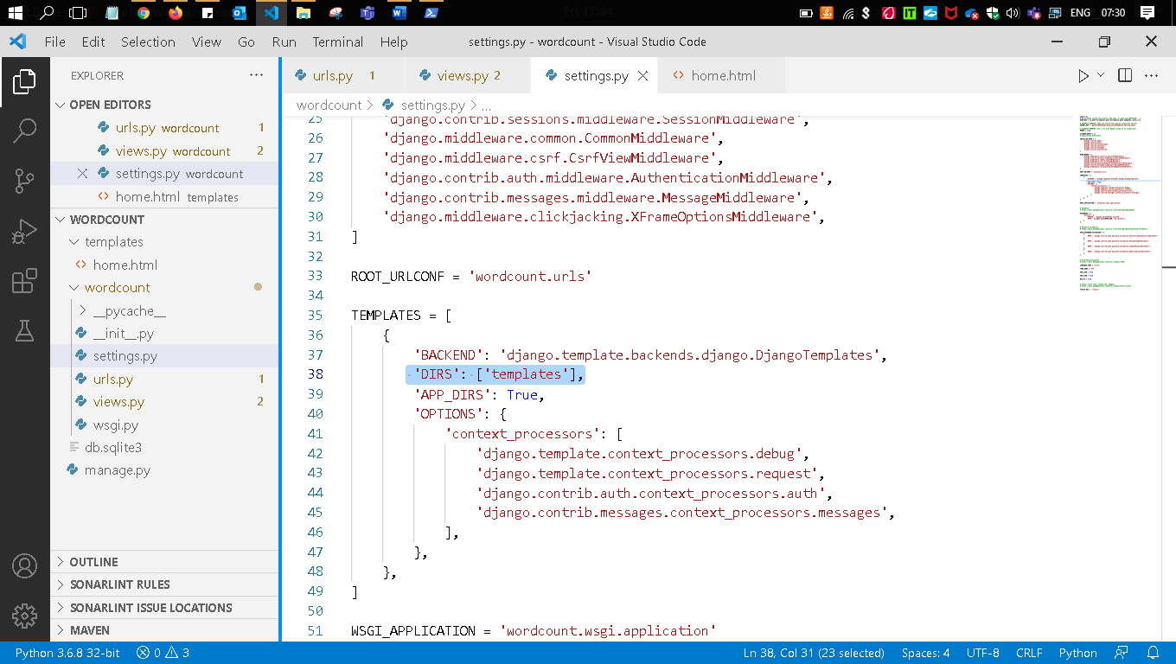
Re run the server agin it will be fixed

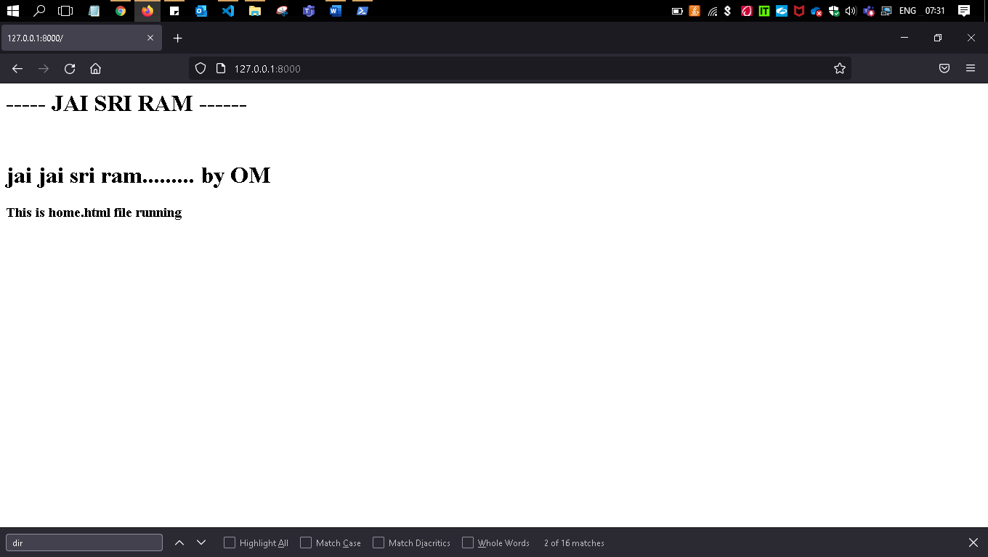

Now we can’t return only html code with render module we can also send some Python codes as well in
How .? lets see that
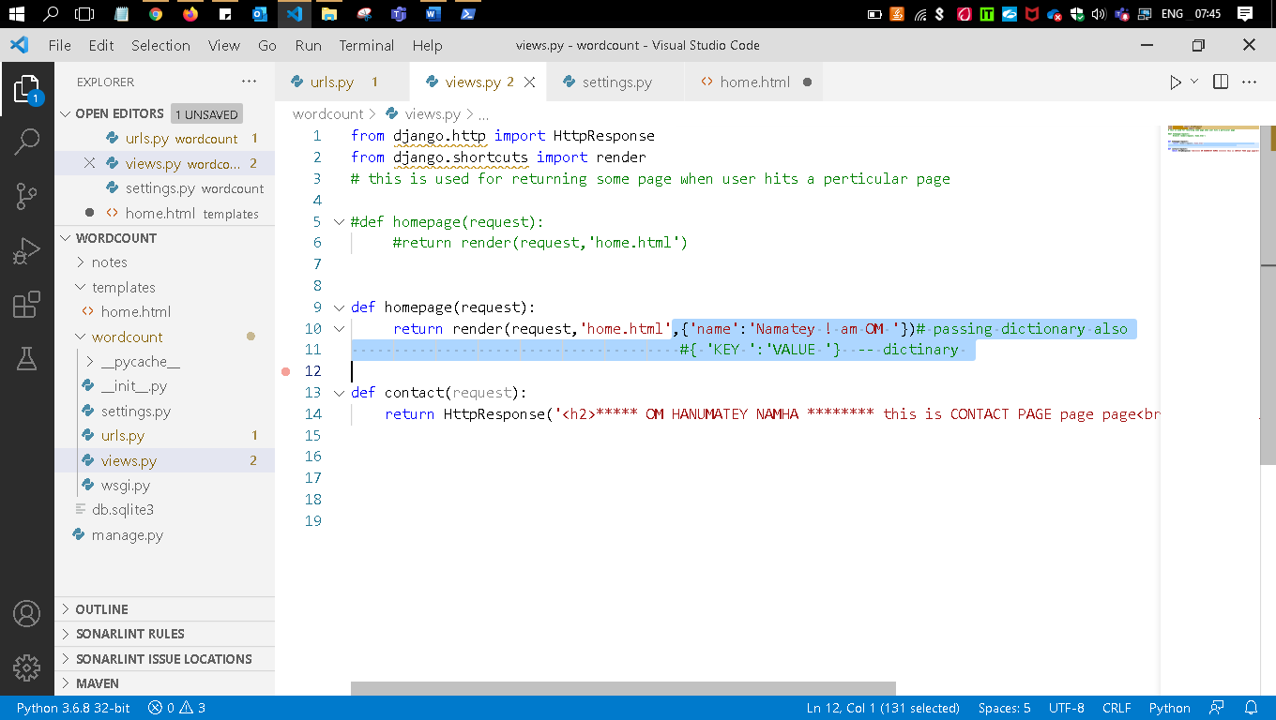
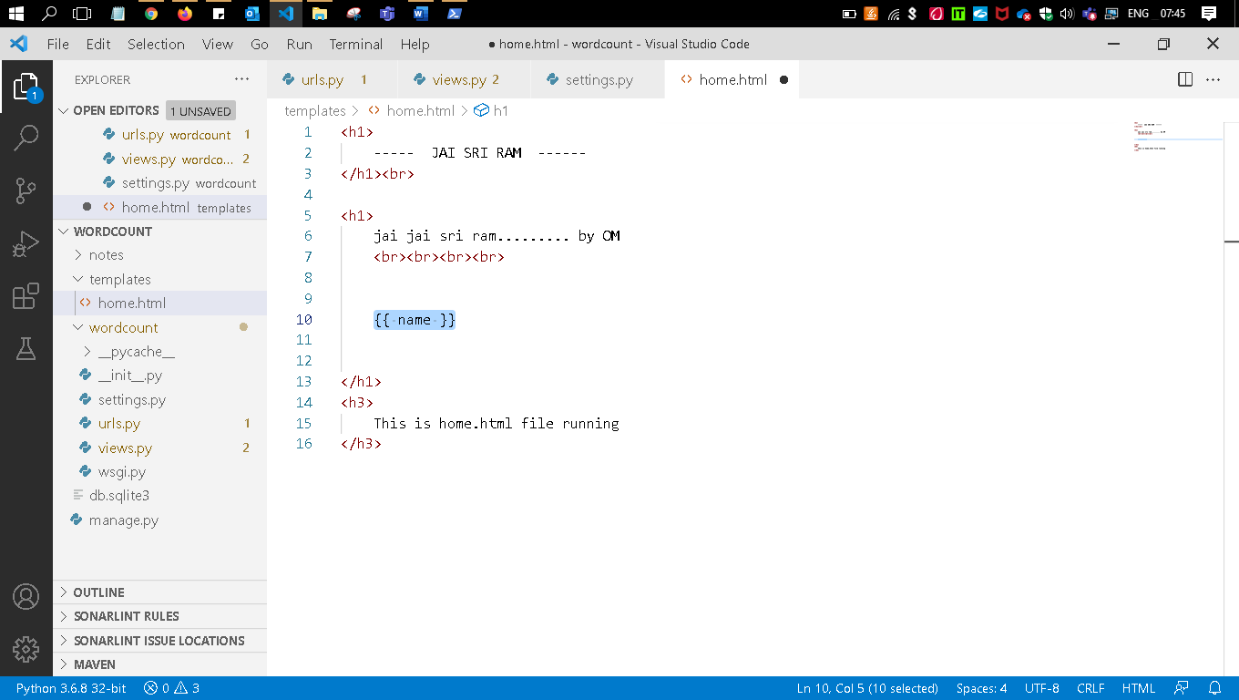
Only 2 changes
Rerun the server
